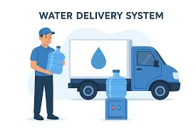  maji water delivery system  THE FUTURE IS HERE. |   Abstract  The report seeks to give interested parties a general overview and understanding of the Maji Water Delivery System.  Kimani Michael- ENE211-0152/2024  Electrical and Electronics Engineering.

Maji Water Delivery System Report

1. Introduction.
The Maji Water Delivery System is a C++-based software platform designed to automate water ordering, vendor management, rider dispatching, delivery fee calculation, and payment processing. The application implements intelligent dispatch algorithms to improve efficiency in local water delivery services.

2. Problem Statement.
Traditional water vending and delivery businesses often face problems such as poor rider distribution, delayed deliveries, inefficient manual dispatching, and lack of payment agreements, which would sometimes and often lead to losses incurred by the vendors and the riders. The Maji Water Delivery System aims to solve these issues through software automation and smart rider-vendor assignment.

3. Objectives.
- To automate the water ordering process.
- To assign vendors and riders intelligently based on distance.
- To calculate delivery fees automatically.
- To estimate delivery time using rider vehicle speed.
- To calculate commissions and vendor profits automatically.
- To simulate digital payment systems.
- To track profits by the vendors.
- To improve customer satisfaction and delivery efficiency.

4. System Features
- Customer ordering system
- Vendor management
- Rider management
- Nearest vendor selection
- Nearest rider dispatching
- Delivery fee calculation
- ETA estimation
- Commission calculation
- Vendor profit tracking
- Ratings and reviews
- CSV-based data persistence
- Simulated M-Pesa payment system

5. System Architecture
The system follows an object-oriented architecture where all system participants inherit from a common User class. The dispatch engine coordinates vendor and rider selection while the payment system handles transaction simulation.
he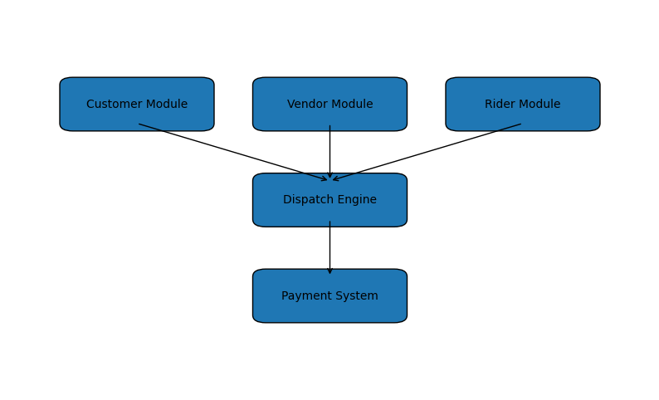

6. Architectural Approach
The application uses Object-Oriented Programming (OOP) principles. Inheritance is used to create reusable structures for customers, vendors, and riders. Encapsulation is applied through private class members and public methods. Polymorphism is also applied in instance of virtual classes used.

7.Prices.
All prices seek to reflect what is in the market and how all vendors price their water products, thus the prices are fixed.
This eliminates manipulation and any increase or decrease of prices if there be so, would be done by the app admin if strong acclaims are made regarding them.
The prices are as follows:
- A 20-l water jerrican – Ksh.10
- A 10-l water jerrican – Ksh.20
- A large water dispenser bottle – Ksh.25
- A small water dispenser bottle – Ksh.50
How the money gotten from sales is divided among the vendor and rider is discussed below.

8.Vendor and Rider Selection.
The vendor, rider and the customer’s locations are all stored in coordinate form.
The vendor’s and rider’s location are permanently stored in the system using vectors, while the customer has to select his/her from a list of 10 locations as will be seen in the code.
This would now assist in vendor and rider selection whereby the nearest vendor would be selected to sell the water while the rider nearer to that vendor will be the one conducting the delivery.
This would ensure efficiency and fast delivery times.
Future upgrades like customer selecting the priority of their delivery either say “fast” or “casual/relaxed” would be incorporated into the system, where now if “fast” the delivery would be done by a motorcycle and if casual or relaxed it’s done by an e-bike or a random selection of a free rider while keeping the criteria of nearest vendor constant to avoid further or expensive charges to the customer.

9. Distance Calculation Algorithm
The system uses the Euclidean Distance Formula to determine the distance between customers, vendors, and riders.
Euclidean distance is the straight-line distance between two points in space. It is the most common method for measuring how far apart objects or data points are and is derived directly from the Pythagorean theorem.
Imagine stretching a perfectly straight string between two points. The length of that string is the Euclidean distance.
In 2D Space
For two points in a Cartesian plane, (P = (x₁, y₁)) and (Q = (x₂, y₂)), the distance, d, is calculated as:
Distance = √ ((x₂ - x₁) ² + (y₂ - y₁) ²)
This formula enables the system to identify the nearest vendor to a customer and the nearest rider to a vendor, assisting in ETA calculation and also the delivery fee calculations.

10. Delivery Fee Calculation
The delivery fee is calculated based on the distance between the customer and the selected vendor.
Delivery Fee = Distance × 10 – Base fee
For example, if the calculated distance is 5 km, the customer is charged 50 Ksh as delivery fee.

11. Rider Commission Calculation
The rider commission is calculated using a base pay system combined with item-based incentives.
- Base Commission = Ksh.10
- 10L bottle = Ksh.5 per bottle
- 20L bottle = Ksh.7.5 per bottle
- Small Dispenser = Ksh.7.5 each
- Large Dispenser = Ksh.10 each
The rider commission is capped at a maximum of 45% of the customer's total payment.

12. Vendor Profit Calculation.
Vendor profit is calculated after deducting rider commission from the customer's total payment.
Vendor Profit = Customer Total Payment - Rider Commission
The system ensures that the vendor receives at least 55% of the customer's total payment.

13. Revenue Sharing Model.
The customer payment is divided between the rider and vendor according to the system's commission algorithm.
- Customer pays for water products and delivery fee.
- Rider receives base pay plus item commissions.
- Vendor receives remaining profit after rider commission deduction.
- Vendor earnings are stored in CSV files for persistence.
- Rider commissions accumulate over multiple deliveries.

14. ETA Calculation.
Estimated delivery time is determined using rider vehicle type.
- E-bike speed is capped at 30 km/h
- Motorcycle speed is at 60 km/h
ETA is calculated using distance and average rider speed.
By the formulae: $Time=\frac{Distance}{averagespeed}$
The ETA is displayed in minutes since the distances used are not in way that the ETA can grow to the hours parameter.

15. Payment System.
The system currently simulates M-Pesa payments using a PIN verification mechanism. Future versions will integrate the Safaricom Daraja API to implement real STK Push functionality.
Also, the customer is given a pay by credit card or cash option where in both cases the payments will be collected by the rider during delivery.
The rider will carry a portable Point of Sale (POS) machine to carry out credit card payments.
A modern phone with the NFC feature can also be used to collect payments done via a credit card.
This is called: a) Tap to Pay.
b) Soft POS.
c) Phone as POS.
d) NFC Card Acceptance.
The following is an image summary of what the system does:
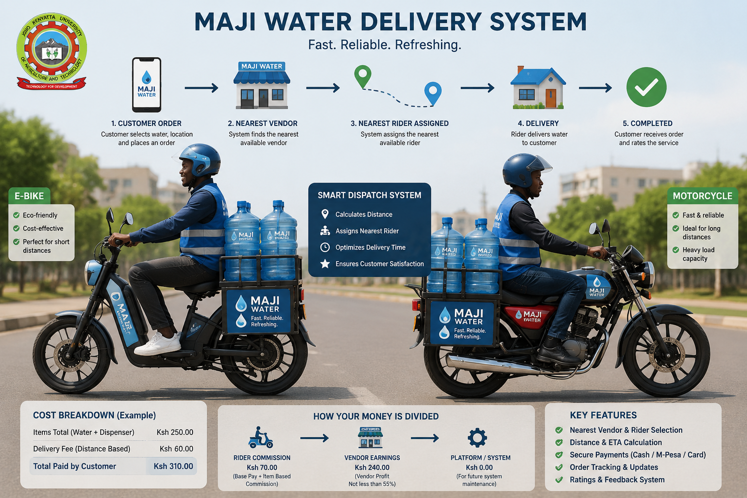

16. Challenges Encountered
- Implementing efficient rider dispatch logic.
- Balancing rider workload distribution.
- Managing data persistence using CSV files.
- Handling real-time order assignment.
- Designing scalable class relationships.

17. Future Improvements
- Daraja API integration.
- Real-time GPS tracking.
- Database integration.
- Admin dashboard.
- Rider and vendor financial advisory.
- Mobile application support.
- Traffic-aware ETA prediction.
- Inventory management.
- Live rider tracking.

18. Conclusion.
The Maji Water Delivery System demonstrates the practical application of software engineering principles in solving real-world logistics and delivery challenges. The system provides a strong foundation for future expansion into a fully functional commercial delivery platform.

